Break a Monolith Application into Microservices with Containers and a Load Balancer (needs modified ecs.yml or use of console)

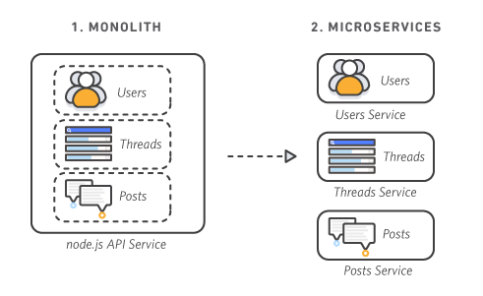

- Containerize the Monolith

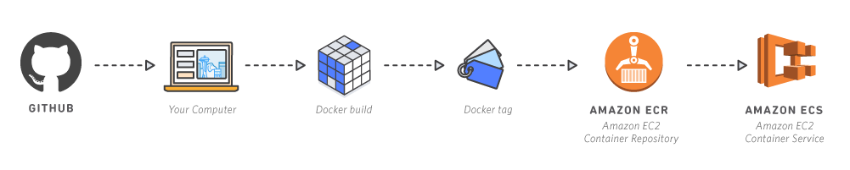
Step 1: Setup
- Install Docker
- Install AWS CLI
- Install Atom, unless another editor is preferred

Step 2: Download or clone the repository

git clone https://github.com/awslabs/amazon-ecs-nodejs-microservices

Step 3: Create a Container Repository in ECR

NOTE: Use your own account id instead of the sample id below

Simply name the repository API.
Record the repository information, e.g.

453545715725.dkr.ecr.us-east-1.amazonaws.com/api

[account-id].dkr.ecr.[region].amazonaws.com/[repo-name].

Step 4: Build and Push the Docker Image

Go to the following subdirectory of your cloned Github repository
2-containerized/services/api

Run
aws ecr get-login-password --region us-east-1 | docker login --username AWS --password-stdin aws_account_id.dkr.ecr.us-east-1.amazonaws.com

Run docker build -t api . (Don’t forget the dot at the end)

You might consider updating the dockerfile (with a newer version of the base image)

Tag the image
docker tag api:latest [account-id].dkr.ecr.[region].amazonaws.com/api:v1
for instance
docker tag api:latest 453545715725.dkr.ecr.us-east-1.amazonaws.com/api:v1

docker push 453545715725.dkr.ecr.us-east-1.amazonaws.com/api:v1 (Note: The instructions have ‘latest’ as the tag)

Find your image in the repository. Also, be careful with future steps, they may assume ‘latest’

You can test the container with
docker run -t -i -p 80:3000 api (maps container port 3000 to host port 80)

Then navigate to the public ip address of the system you are running this on (e.g your Cloud9 EC2 instance) with e.g. ip-address/api/threads

Also, if you cannot build an ECR repository, you can use a private repository in another registry
https://docs.aws.amazon.com/AmazonECS/latest/developerguide/private-auth-container-instances.html

Dockerhub registry:
https://index.docker.io/v1/
With my krkrepository

docker push kristofrk/krkrepository:tagname

docker pull registry.hub.docker.com/kristofrk/krkrepository
(log on with your Docker authentication first)
Or:
docker run -t -i -p 80:3000 registry.hub.docker.com/kristofrk/krkrepository2

Proceed with Module 2, referring to the instance in Docker Hub.

e.g. registry.hub.docker.com/kristofrk/krkrepository2
Note: This should be a public repository.
Test by typing the url of the container host instance.

- Deploy the Monolith

Step 1: Build an ECS Cluster with CloudFormation

- Navigate to the AWS CloudFormation console.
- Select Create Stack.
- Select 'Upload a template to Amazon S3' and choose the ecs.yml file from the GitHub project at amazon-ecs-nodejs-microservice/2-containerized/infrastructure/ecs.yml Select Next.
- For stack name, enter BreakTheMonolith-Demo. Keep the other parameter values the same:
  - Desired Capacity = 2
  - InstanceType = t2.micro
  - MaxSize = 2

No modification necessary for other parameters. Click ‘Create’.
The CloudFormation Stack can be viewed in the Designer.

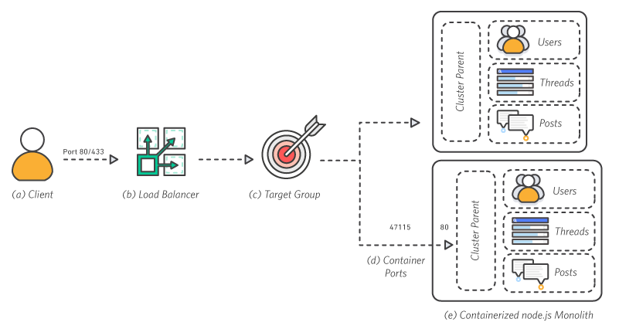

You can also use the command line. However, you have to modify the CloudFormation stack ecs.yml to NOT create roles
$ aws cloudformation deploy \
--template-file infrastructure/ecs.yml \
--region us-east-1 \
--stack-name Nodejs-Microservices \
--capabilities CAPABILITY_NAMED_IAM
Step 2: Check that the Cluster is running
Go to the ECS Console. Extra task: Update the agents
Also look at the events list for the CloudFormation Stack to understand which resources have been created.
Note: These are not serverless containers, so there are EC2 instances to support them.

Step 3: Write a Task Definition (in the ECS Console)

The task definition tells Amazon ECS how to deploy your application containers across the cluster.
- Navigate to the 'Task Definitions' menu on the left side of the Amazon ECS console.
- Select Create new Task Definition.
- Select Launch Type ECS
- Task Definition Name = api.
- Select Add Container.
- Specify the following parameters.
  - If a parameter is not defined, leave it blank or with the default settings: Container name = api image = [account-id].dkr.ecr.[region].amazonaws.com/api:v1 (this is the URL of your ECR repository image from the previous step).
  - Be sure the tag :v1 matches the value you used in module 1 to tag and push the image. Memory = Hard limit: 256 Port mappings = Host port:0, Container port:3000 CPU units = 256
  - Note: server.js listens on port 3000
- Select Add.
- Select Create.
- You will now be able to see your task called api

Step 4: Configure the Application Load Balancer
Check your VPC Name: If this is not your first time using this AWS account, you may have multiple VPCs. It is important to configure your Target Group with the correct VPC.
- Navigate to the Load Balancer section of the EC2 Console.
- You should see a Load Balancer already exists named demo.
- Select the checkbox to see the Load Balancer details.
- Note the value for the VPC attribute on the details page.

Configure the ALB Target Group
- Navigate to the Target Group section of the EC2 Console.
- Select Create target group.
- Configure the Target Group (do not modify defaults if they are not specified here):
  - Name = api
  - Protocol = HTTP
  - Port = 80
  - VPC = select the VPC that matches your Load Balancer from the previous step. This is most likely NOT your default VPC.
  - Advanced health check settings: Healthy threshold = 2 Unhealthy threshold = 2 Timeout = 5 Interval = 6.
- Select Create.

Step 5: Add a listener to the Load Balancer

- Navigate to the Load Balancer section of the EC2 Console.
- You should see a Load Balancer already exists named demo.
- Select the checkbox to see the Load Balancer details.
- Select the Listeners tab.
- Select Create Listener:
  - Protocol = HTTP
  - Port = 80
  - Action: Forward To:
  - Default target group = api

- Click Create.

Step 6: Deploy the Monolith

Now, you will deploy the monolith as a service onto the cluster.
- Navigate to the 'Clusters' menu on the left side of the Amazon ECS console.
- Select your cluster: BreakTheMonolith-Demo-ECSCluster.
- Under the services tab, select Create.
- Configure the service (do not modify any default values): Service name = api Number of tasks = 1
- Select Configure ELB:
  - ELB Type = Application Load Balancer.
  - For IAM role, select BreakTheMonolith-Demo-ECSServiceRole.
  - Select your Load Balancer ELB name = demo.
  - Select Add to ELB.
- Add your service to the target group:
  - Listener port = 80:HTTP
  - Target group name = select your group: api.

- Select Save.

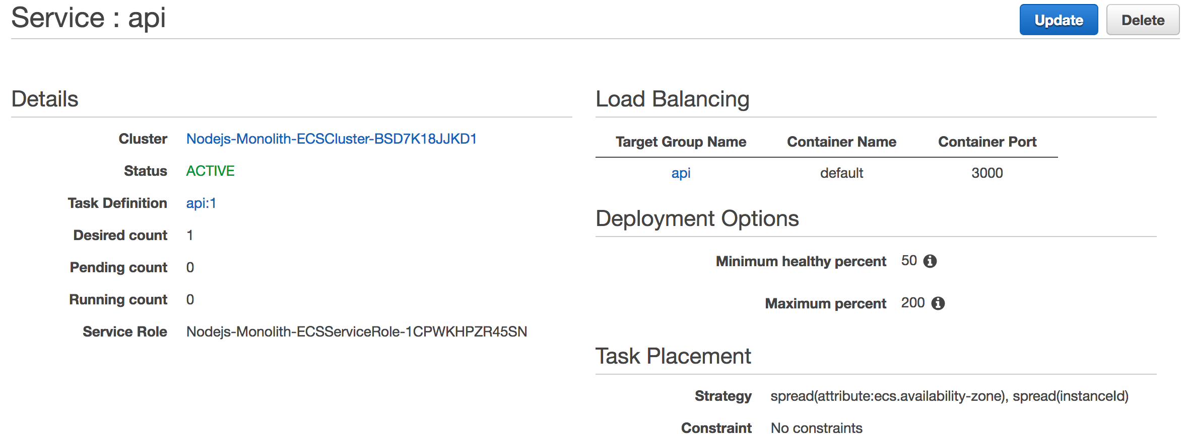
- Select Create Service.
- Select View Service.

Step 7: Test the Monolith

Validate your deployment by checking if the service is available from the internet and pinging it.
To Find your Service URL:
- Navigate to the Load Balancers section of the EC2 Console.
- Select your load balancer demo.
- Copy and paste the value for DNS name into your browser.
- You should see a message 'Ready to receive requests'.
See Each Part of the Service: The node.js application routes traffic to each worker based on the URL. To see a worker, simply add the worker name api/[worker-name] to the end of your DNS Name like this:
- http://[DNS name]/api/users
- http://[DNS name]/api/threads
- http://[DNS name]/api/posts
You can also add a record number at the end of the URL to drill down to a particular record. Like this: http://[DNS name]/api/posts/1 or http://[DNS name]/api/users/2
Manual execution steps

1. Use the ECS Console to build the BreakTheMonolith-Demo cluster manually. Choose the EC2 Linux+Networking Template, use the same parameters as with the project instructions (Desired Capacity, Instance Type, MaxSize), and defaults otherwise
2. Modify the inbound rules for the security group to allow HTTP on port 80, SSH on port 22, and Custom TCP on port range 31000 - 61000 from your ECS security group
3. Create a task definition (as in the module)
3. Create target group api (as in the module)
4. Create an application load balancer demo, in the VPC that got created with your ECS cluster, with a listener that routs to the target group api
5. Create the service and test it (as in the module)

- Break the Monolith (into Microservices)
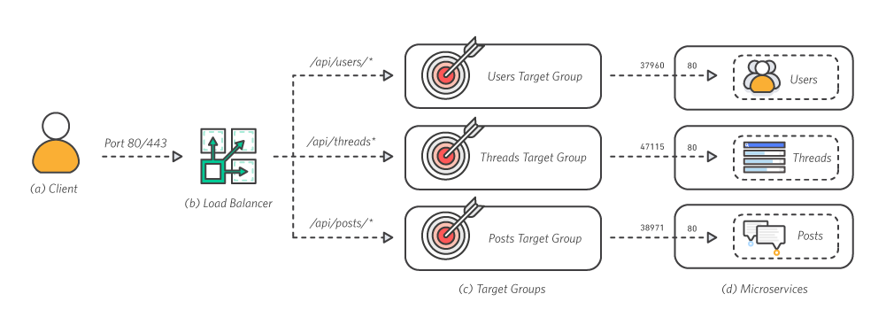
Reasons for using Microservices
- Failure isolation
- Security isolation
- Independent scaling
- Development velocity

Step 1: Create 3 repositories, one for each service

- Navigate to the Amazon ECR Console.
- Select Create Repository
- Repository name:
  - users
  - threads
  - posts

- Record the repositories information: [account-id].dkr.ecr.[region].amazonaws.com/[service-name]

Step 2: Build and Push Images for each Service

Go to ~/amazon-ecs-nodejs-microservices/3-microservices-master/services
Build and Tag Each Image
- In the terminal, run docker build -t [service-name] ./[service-name] Example: docker build -t posts ./posts
After the build completes, tag the image so you can push it to the repository:
docker tag [service-name]:latest [account-id].dkr.ecr.[region].amazonaws.com/[service-name]:v1
example:
docker tag posts:latest 453545715725.dkr.ecr.us-east-1.amazonaws.com/posts:v1
docker tag users:latest 453545715725.dkr.ecr.us-east-1.amazonaws.com/users:v1
docker tag threads:latest 453545715725.dkr.ecr.us-east-1.amazonaws.com/threads:v1

- Run docker push to push your image to ECR:
docker push [account-id].dkr.ecr.[region].amazonaws.com/[service-name]:v1
docker push 453545715725.dkr.ecr.us-east-1.amazonaws.com/posts:v1
docker push 453545715725.dkr.ecr.us-east-1.amazonaws.com/users:v1
docker push 453545715725.dkr.ecr.us-east-1.amazonaws.com/threads:v1

If you navigate to your ECR repository, you should see your images tagged with v1.
♻ Repeat these steps for each microservice image.

- Deploy Microservices

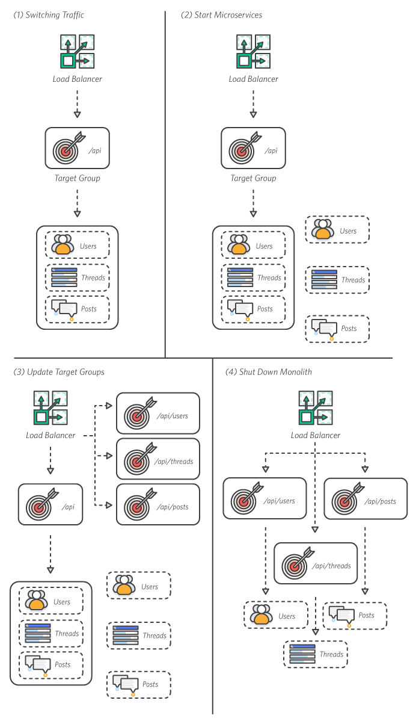
Step 1: Write task definitions for each service

You will deploy three new microservices onto the same cluster you have running from Module 2. Like in Module 2, you will write Task Definitions for each service.
⚐ NOTE: It is possible to add multiple containers to a task definition - so feasibly you could run all three microservices as different containers on a single service. This however, would still be monolithic as every container would need to scale linearly with the service. Your goal is to have three independent services and each service requires its own task definition running a container with the image for that respective service.
You can either these Task Definitions in the console UI, or speed things up by writing them as JSON. To write the task definition as a JSON file, select Configure via JSON at the bottom of the new Task Definition screen.
The parameters for the task definition are:
- Name = [service-name]
- Image = [service ECR repo URL]:v1 (was ‘latest’ in web instructions)
- cpu = 256
- memory = 256
- Container Port = 3000
- Host Post = 0

Or JSON

Step 2: Configure the Load Balancer Target Groups

Configure the Target Groups
- Navigate to the Target Group section of the EC2 Console.
- Select Create target group.
- Configure the Target Group (do not modify defaults if they are not specified here): Name = [service-name] Protocol = HTTP Port = 80 VPC = select the VPC that matches your Load Balancer from the previous step.
  - Advanced health check settings: Healthy threshold = 2 Unhealthy threshold = 2 Timeout = 5 Interval = 6
- Select Create.

♻ Repeat this process to create a target group for each service:
- posts
- threads
- users

Finally, Create a Fourth Target Group
- drop-traffic
This target group is a 'dummy' target. You will use it to keep traffic from reaching your monolith after your microservices are fully running. You should have 5 target groups total in your table.

Step 3: Create Listener Rules to forward to target groups

Update Listener Rules
- Select View/edit rules > for the listener.
- Select the + and insert rule.
- The rule criteria are:
  - IF Path = /api/[service-name]* THEN Forward to [service-name]
  - For example: Path = /api/posts* forward to posts
- Create four new rules, one to maintain traffic to the monolith, and one for each service. You will have a total of five rules, including the default. Ensure you add your rules in this order:
  - api: /api* forwards to api
  - users: /api/users* forwards to users
  - threads: /api/threads* forwards to threads
  - posts: /api/posts* forwards to posts

Default rule comes last. Note: No / before *

Step 4: Deploy Microservices

Now, you will deploy your three services onto your cluster. Repeat these steps for each of your three services:
- Navigate to the 'Clusters' menu on the left side of the Amazon ECS console.
- Select your cluster: BreakTheMonolith-Demo-ECSCluster.
- Under the services tab, select Create.
- Configure the service (do not modify any default values) Task definition = select the highest value for X: [service-name]:X (X should = 1 for most cases) Service name = [service-name] Number of tasks = 1
- Select Configure ELB
  - ELB Type = Application Load Balancer
  - For IAM role, select BreakTheMonolith-Demo-ECSServiceRole
  - Select your Load Balancer demo
  - Select Add to ELB
- Add your service to the target group:
  - Listener port = 80:HTTP
  - Target group name = select your group: [service-name]
- Select Save.
- Select Create Service.
- Select View Service.
It should only take a few seconds for all your services to start. Double check that all services and tasks are running and healthy before you proceed.
Step 4: Switch over and turn off monolith

Right now, your microservices are running, but all traffic is still flowing to your monolith service.
Update Listener Rulers to Re-Route Traffic to the Microservices:
- Navigate to the Load Balancer section of the EC2 Console
- Select View/edit rules > for the listener on the demo load balancer.
- Delete the first rule (/api* forwards to api).
- Update the default rule to forward to drop-traffic.

Turn off the Monolith: Now, traffic is flowing to your microservices and you can spin down the Monolith service.
- Navigate back to your Amazon ECS cluster BreakTheMonolith-Demo-ECSCluster.
- Select the api service and then Update.
- Change Number of Tasks to 0.
- Select Update Service.

You have switched over without any downtime.

- Clean up

Doing the project with Fargate.

- Create an ECS Cluster with Fargate – use defaults
- Create a task api2. Choose 3000 as the container port, this is where server.js listens.
- Create a service (w/o loadbalancer)
- Use the task api2
- Select 1 task
- Use defaults
- Modify the security group to allow all traffic to port 3000 (the container listens on port 3000)
- Invoke the service with public_ip:3000
- Create microservices task definitions for Fargate.
- Create services with loadbalancer, proceed as with the EC2 example

